Pune District Education Associations
Seth Govind Raghunath Sable College of Pharmacy, Saswad

Report
Online IPR awareness Program Under the flagship of KAPILA & NIPAM
Title of the Event: Online IPR awareness Program in association with MIC and AICTE Under the flagship of KAPILA & NIPAM.
Name of Activity: Intellectual Property Rights Awareness Program
Date & Day: Monday 16th January 2023
Venue: Online mode (Zoom platform)
No. of Participants: 259

The institute organized online IPR awareness Program Under in association with MIC and AICTE Under the flagship of KAPILA & NIPAM on 16th January 2023 using Zoom platform. The program started with welcome speech by Dr. Smita Pawar, Vice- principal & coordinator of the program. She expressed her gratitude to the Ministry of Education's Innovation Cell (MIC), the AICTE, and the program's goal in a brief. The welcome speech was followed by the address by Principal Dr. Rajashree Chavan. She shared an outline of the program's objective and commented on the current state of innovation and intellectual rights in her speech. Dr. Smita Pawar introduced the speaker of the program Ms. Mehak Batra, Examiner of Patents & Designs Patent Office, Mumbai, Department for Promotion of Industry and Internal Trade (DPIIT), Ministry of Commerce and Industry, Govt of India. The session continued with the presentation by Ms. Mahak Batra on IPR. She has enlightened the audience on various aspects of trademark, copy rights, designs etc in very lucid manner. She further gave insights on how to apply for these different types of patents. Her talk was followed by question answer session. The session concluded with vote of thanks by IQAC coordinator, Mrs. Jayashree Jagtap,
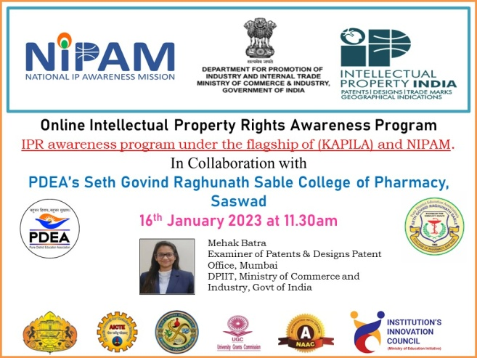

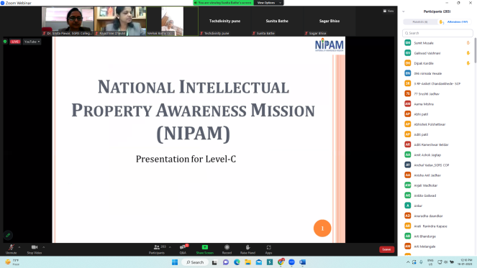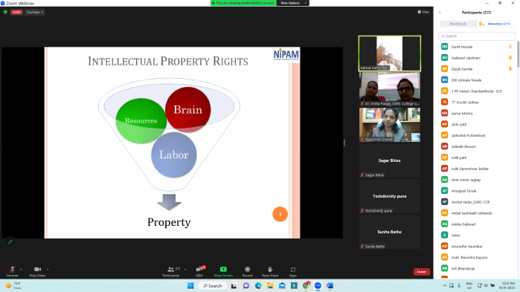

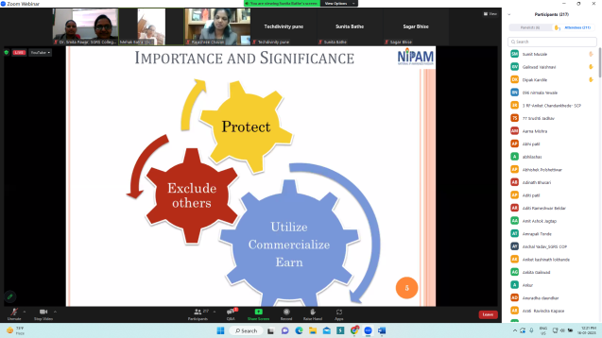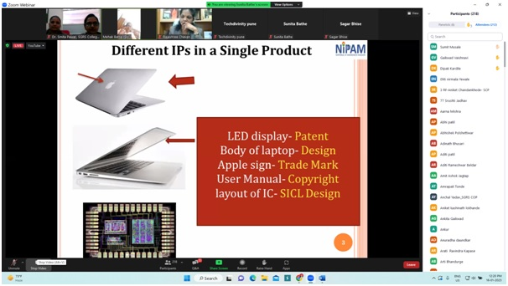

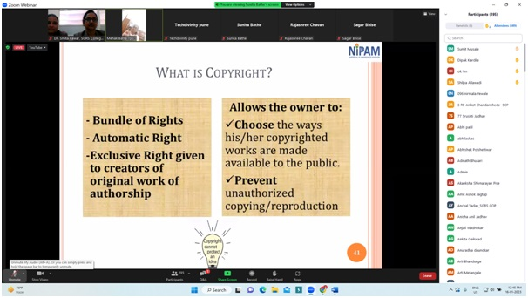

Dr. Smita Pawar 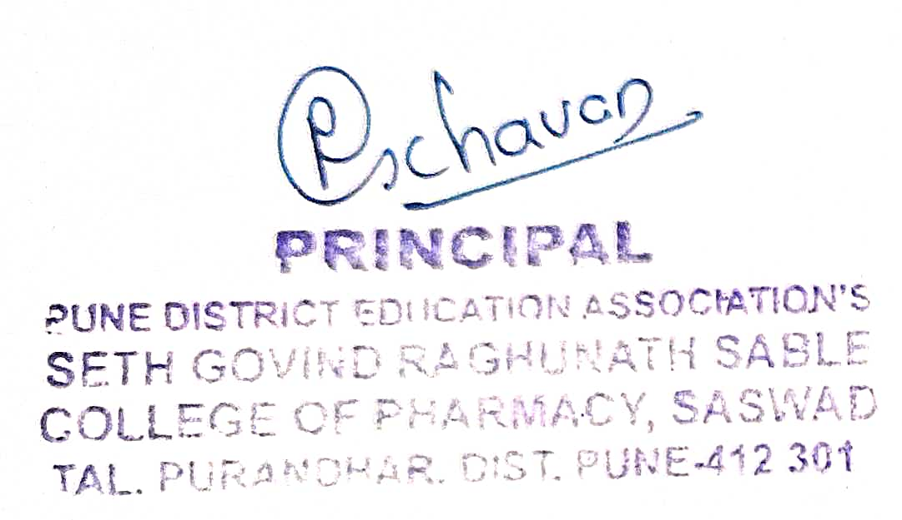
Coordinator

